**[10th Nov 2022]**

|  |  |  |  |  |  |
| --- | --- | --- | --- | --- | --- |
| **SN** | **Module** | **Sub – Module** | **Issue** | **status** | **Type** |
| 1 | TT | Timesheet -> current tab | 1. icon colour should be change which is in status column.  2. popup comes on icon hover which is in status column should be managed and on icon hand icon should be there. | open | Design |

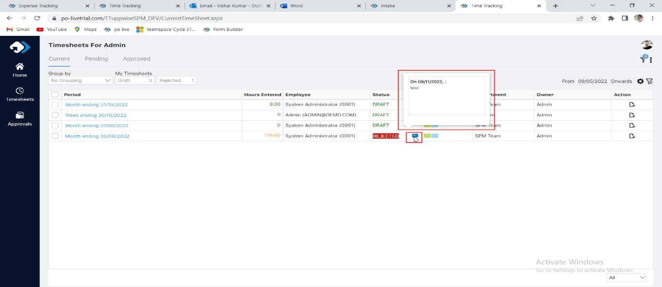

|  |  |  |  |  |  |
| --- | --- | --- | --- | --- | --- |
| **SN** | **Module** | **Sub – Module** | **Issue** | **status** | **Type** |
| 2 | TT | Timesheet -> current tab | Hover popup is going to hide hover on icon of first row. | open | Design |

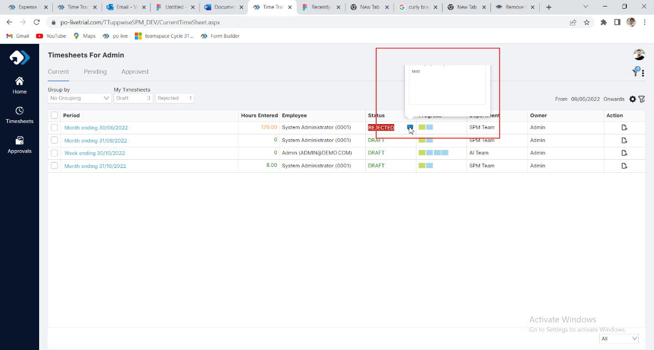

|  |  |  |  |  |  |
| --- | --- | --- | --- | --- | --- |
| **SN** | **Module** | **Sub – Module** | **Issue** | **status** | **Type** |
| 3 | TT | Timesheet -> current tab->filter popup | Date field are not vertical aligned | open | Design |

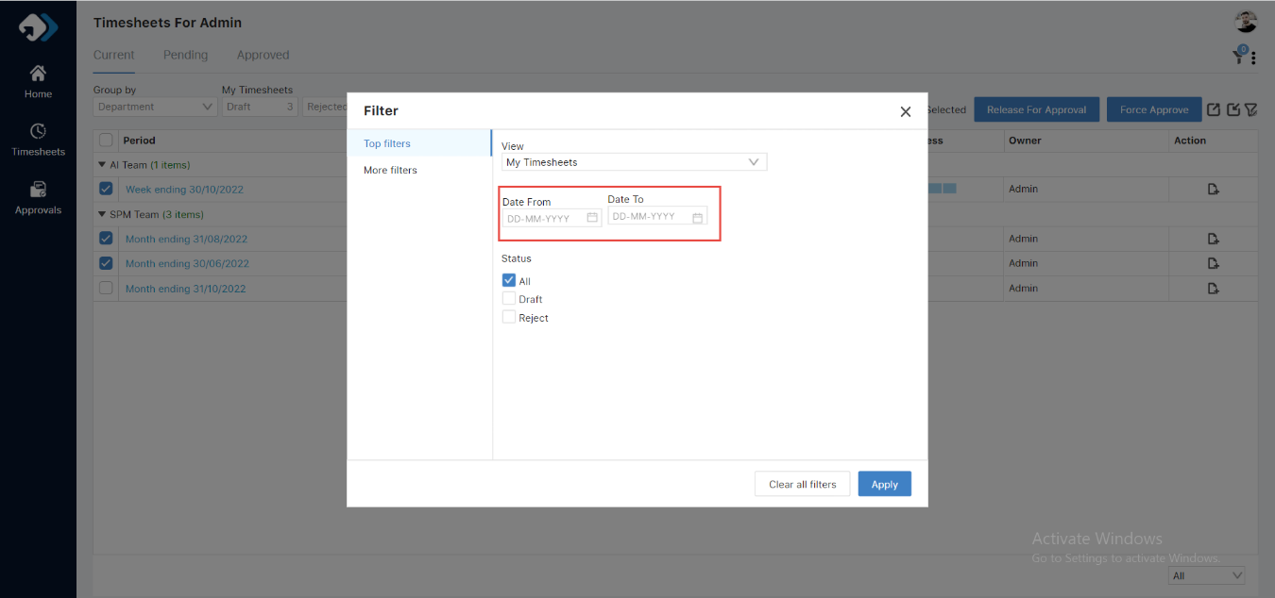

|  |  |  |  |  |  |
| --- | --- | --- | --- | --- | --- |
| **SN** | **Module** | **Sub – Module** | **Issue** | **status** | **Type** |
| 4 | TT | Timesheet -> current tab->Force Approval popup | Text is too small | open | Design |

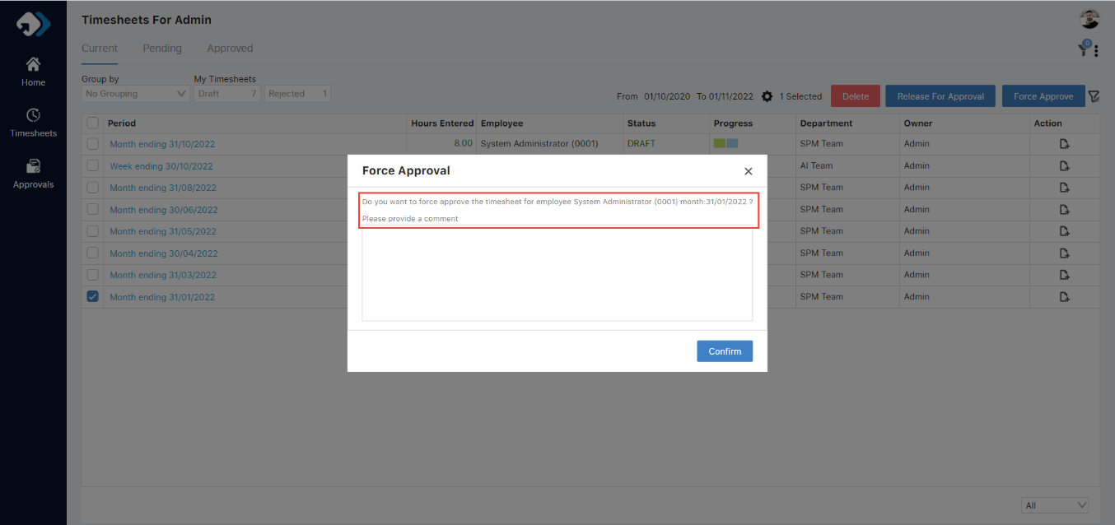

|  |  |  |  |  |  |
| --- | --- | --- | --- | --- | --- |
| **SN** | **Module** | **Sub – Module** | **Issue** | **status** | **Type** |
| 5 | TT | Timesheet -> current tab | Buttons gap is not same | open | Design |

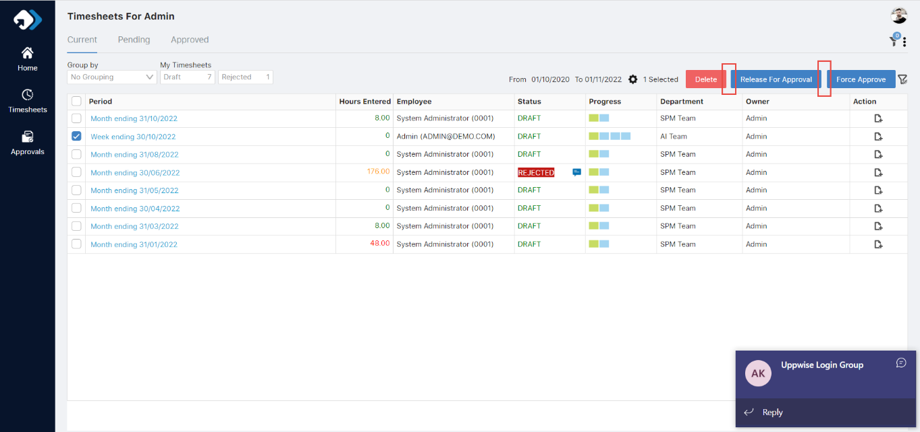

|  |  |  |  |  |  |
| --- | --- | --- | --- | --- | --- |
| **SN** | **Module** | **Sub – Module** | **Issue** | **status** | **Type** |
| 6 | TT | Timesheet -> current tab-> Progress | Size of subtitle should be 11px | open | Design |

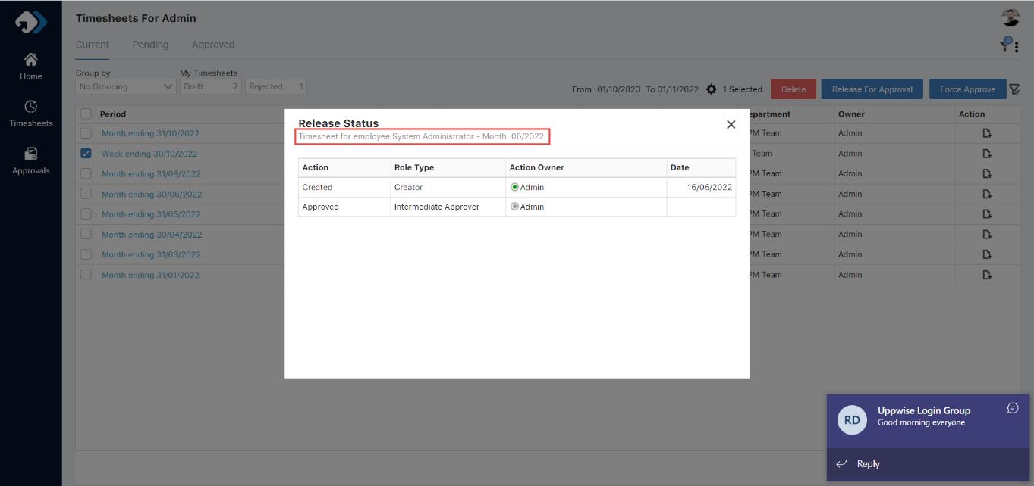

|  |  |  |  |  |  |
| --- | --- | --- | --- | --- | --- |
| **SN** | **Module** | **Sub – Module** | **Issue** | **status** | **Type** |
| 7 | TT | Timesheet -> current tab-> New timesheet popup | 1.Calendar icon should be changed  2.sub title size should be changed. | open | Design |

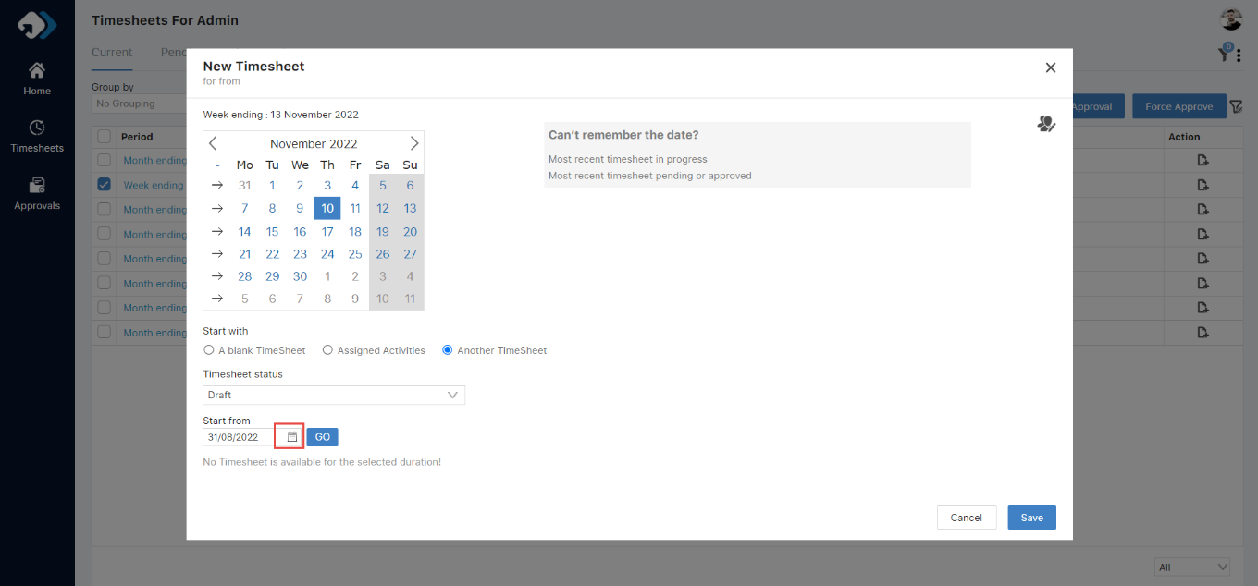

|  |  |  |  |  |  |
| --- | --- | --- | --- | --- | --- |
| **SN** | **Module** | **Sub – Module** | **Issue** | **status** | **Type** |
| 8 | TT | Timesheet -> pending tab-> New timesheet popup | Hover popup position is not proper | open | Design |

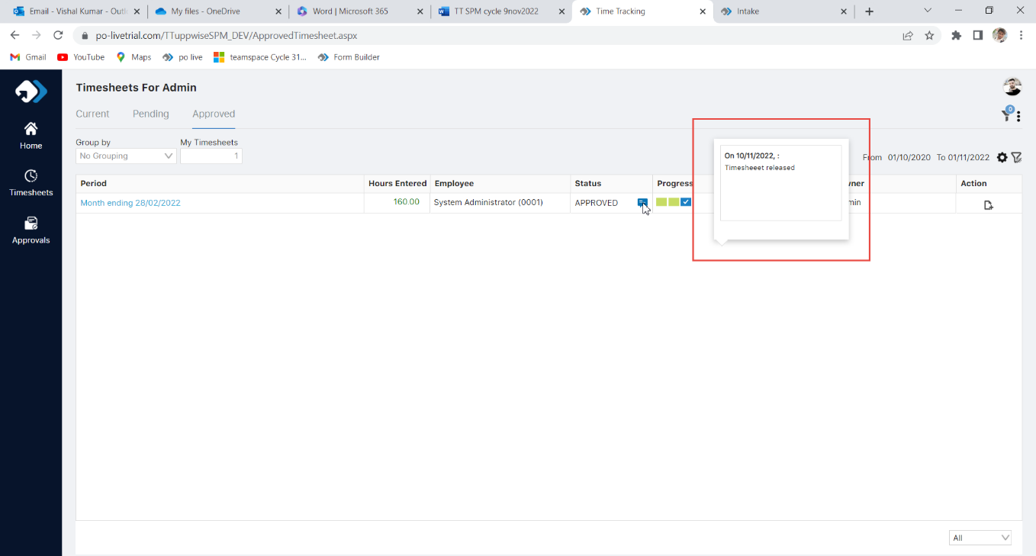

|  |  |  |  |  |  |
| --- | --- | --- | --- | --- | --- |
| **SN** | **Module** | **Sub – Module** | **Issue** | **status** | **Type** |
| 9 | TT | Timesheet -> Approved tab-> customize view | Calendar position is not proper | open | Design |

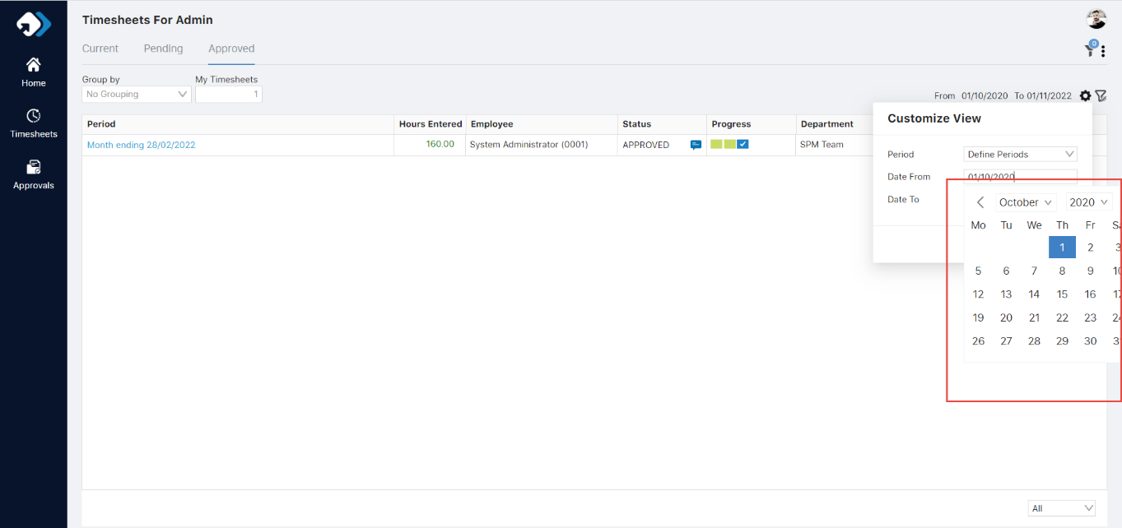

|  |  |  |  |  |  |
| --- | --- | --- | --- | --- | --- |
| **SN** | **Module** | **Sub – Module** | **Issue** | **status** | **Type** |
| 10 | TT | Timesheet -> Approved tab-> customize view | Icon of action column is not canter aligned | open | Design |

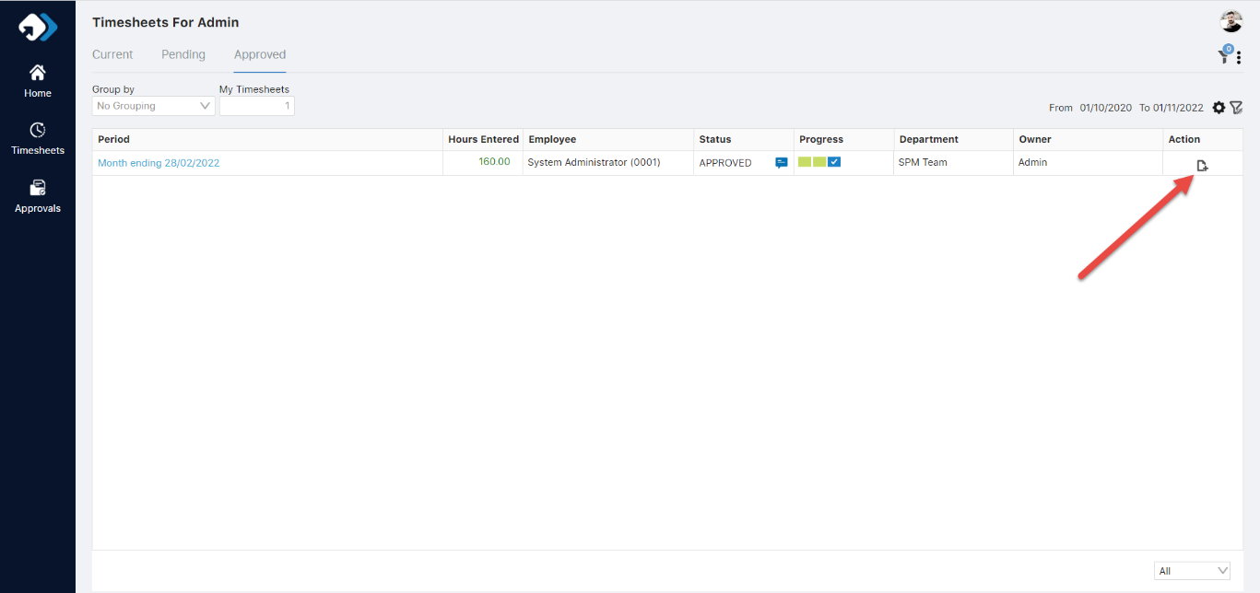

|  |  |  |  |  |  |
| --- | --- | --- | --- | --- | --- |
| **SN** | **Module** | **Sub – Module** | **Issue** | **status** | **Type** |
| 11 | TT | Timesheet -> Current tab-> open period column element | Grid not covered 100% width but after drag the column width, it covers 100% width | open | Design |

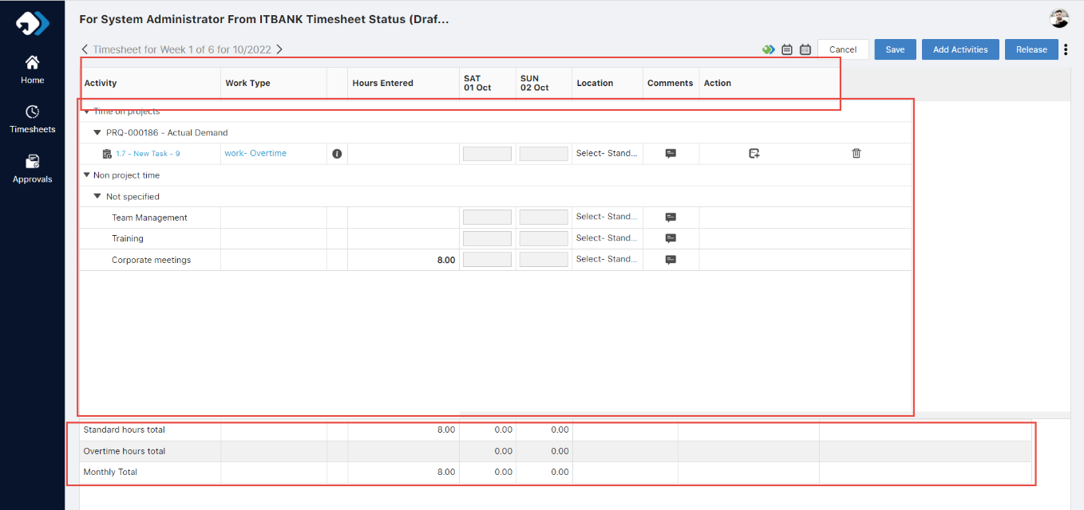

|  |  |  |  |  |  |
| --- | --- | --- | --- | --- | --- |
| **SN** | **Module** | **Sub – Module** | **Issue** | **status** | **Type** |
| 12 | TT | Timesheet -> Current tab-> open period column element - > Open activity details popup | Tab background is not with proper width | open | Design |

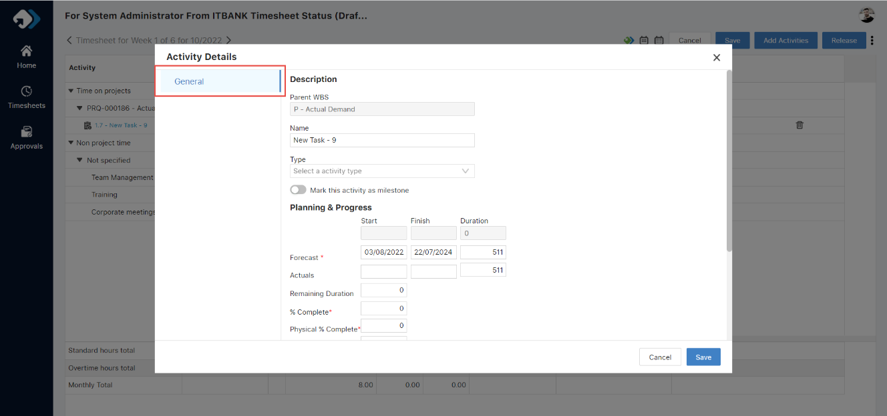

|  |  |  |  |  |  |
| --- | --- | --- | --- | --- | --- |
| **SN** | **Module** | **Sub – Module** | **Issue** | **status** | **Type** |
| 13 | TT | Timesheet -> Approved tab | Action column icon have no new tooltip | open | Design |

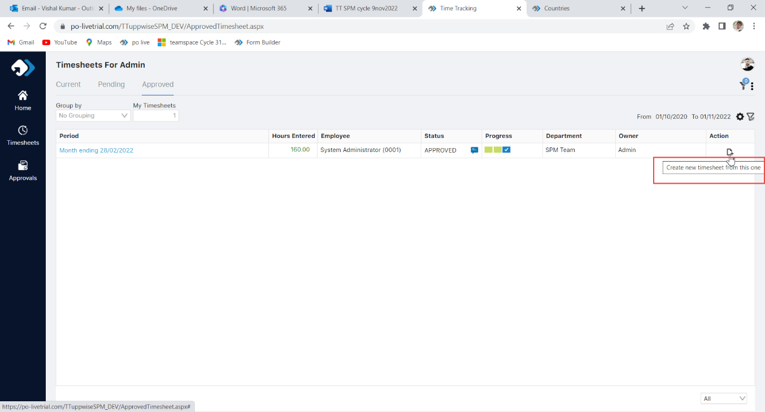

|  |  |  |  |  |  |
| --- | --- | --- | --- | --- | --- |
| **SN** | **Module** | **Sub – Module** | **Issue** | **status** | **Type** |
| 14 | TT | Timesheet -> pending tab-> customize view | Period text size is not same as others | open | Design |

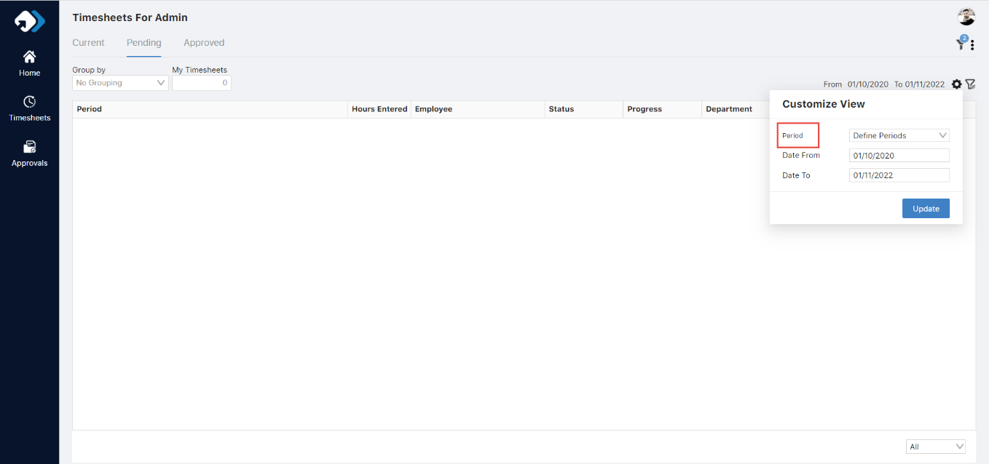

|  |  |  |  |  |  |
| --- | --- | --- | --- | --- | --- |
| **SN** | **Module** | **Sub – Module** | **Issue** | **status** | **Type** |
| 15 | TT | Timesheet -> Current tab | On check and uncheck the row, the icon position of filter is up and down | open | Design |

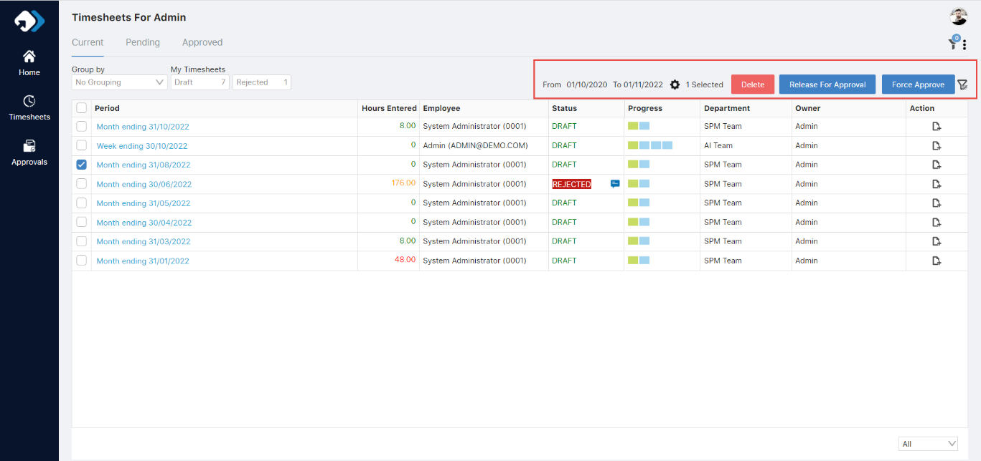

|  |  |  |  |  |  |
| --- | --- | --- | --- | --- | --- |
| **SN** | **Module** | **Sub – Module** | **Issue** | **status** | **Type** |
| 16 | TT | Timesheet -> Current tab-> period -> add activities -> filter popup -> Advance filter tab | 1. Design should be managed. 2. Click on plus icon dimmer of filter popup is disappear | open | functional |

